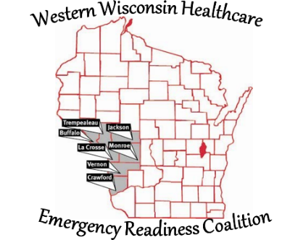
Western Wisconsin Healthcare Emergency Readiness Coalition
Buffalo Crawford Jackson La Crosse Monroe
Trempealeau Vernon Counties & Ho-Chunk Nation

Implementation Date: August 5, 2021

Affirmative Action Plan, Policy #2

It is the policy of the Western Wisconsin Healthcare Emergency Readiness Coalition Region 4, Inc not to discriminate against any employee, applicant, appointee, or anyone running for election to the board because of age, race, religion, color, handicap, sex, physical condition, developmental disability, sexual orientation or national origin. This policy shall include, but not be limited to, the following: recruitment and employment, promotion, demotion, appointment, transfer, compensation, selection for training including apprenticeship, layoff and termination, and any grant requestor.

The Chair of HERC has been appointed the Equal Employment Opportunity Officer. The Chair or Chair’s designee is responsible for planning and implementing our affirmative action program as well as for its day-to-day monitoring of affirmative action related decisions and activities. All personnel who are responsible for hiring and promoting employees and for the development and implementation of programs or activities are charged to support this program. They shall provide leadership in implementing affirmative action goals and initiatives.

During the life of contract with the State of Wisconsin, the HERC shall comply with s.16.765, Wis. Stats., state regulations and federal laws relating to equal employment opportunities and affirmative action. The company shall continue to work cooperatively with government and community organizations to take affirmative action to ensure equal employment and advancement opportunities. This signed policy shall remain in effect until the appointment of a new Chair of the HERC.

