Responding to an MCI ALERT in EMResource (WITrac)
Login: https://emresource.juvare.com/login
Click on announcement banner at the top of the home page. Note that MCI Alerts are a RED banner.
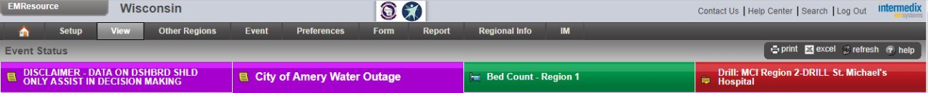
By clicking on the MCI banner it displays the response screen. Click on dash next to each category RED/YELLOW/GREEN
Enter the number of each category that your ED can take. Please note that this is an estimate, you may receive many more or less depending on circumstances. Then Click “Save”.
MCI Response is an ER Responsibility

Communication is KEY! Talking with your ER MD immediately and consider activating your MCI plan. Waiting to do so can cause delay in treating patients. Here are a few suggestions to help the ER staff determine what numbers to put in when requested. Please share with your leaders or whoever will make the decisions.
A MCI BEDCOUNT IS A SNAPSHOT OF TIME OF THE “RIGHT NOW.”
When you are alerted via WITrac to complete the MCI bed count, you need to be as realistic as possible to what type of patients and how many you could safely take at the time of the alert.
There are a few things that you might need to consider:
Are there staff I can call in and if so, how fast can they be here to help?
Do I have OR’s open and available?
Do we have extra Physicians for critical patients?
How many support staff are available? CT, Lab, blood bank, registration etc.
The number of patients you are able to initially take will differ greatly depending on time of day. DAYS/PM/NOC?
Is your facility likely to receive walk ins from this event? Adjust for that.

Remember this is just a snap shot in time of availability; this could change every 30 seconds, so a best guess is needed. Another bed count could be requested about 15-30 minutes after patients start to arrive, in the case more patients need to be placed. Depending on the incident you could get more or less patients than reported so plan ahead and prepare for more!
CRITICAL ACCESS HOSPITALS: - please consider this. If your normal process is to stabilize and transfer a critical patient, take into consideration that the normal receiving facilities may be at maximum capacity due to this event and you may need to keep the patients for longer than normal.

RED: CRITICAL/LIFE – THREATENING Needs ABC’s, lots of resources
YELLOW: DELAYED Treatment/Moderate care needed- these could go to another department to be treated if able.
GREEN: Walking wounded- ok to wait for care in triage

