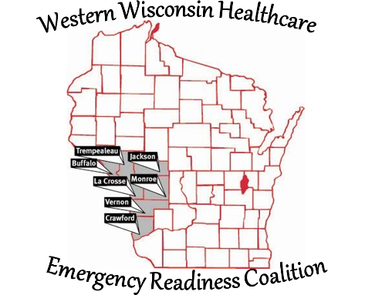
Western Wisconsin Healthcare Emergency Readiness Coalition
Buffalo Crawford Jackson La Crosse Monroe
Trempealeau Vernon Counties & Ho-Chunk Nation

Bill Klemp - Coordinator
43 Campus Lane
Janesville, WI 53545
Cell: 608-751-0698
Email: loren.klemp@gmail.com

7/7/2020

SUBJECT: Region Hospital Address and Contact Information

Black River Memorial Hospital - Critical Access Hospital
711 W Adams St
Black River Falls, WI 54615
715.284.5361

Crossing Rivers Health - Critical Access Hospital
37868 Us Highway 18
Prairie Du Chien, WI 53821
608.357.2000

Gundersen Lutheran Medical Center - Short Term Acute Care Hospital, Level 2 Trauma Center
1900 South Ave
La Crosse, WI 54601
608.782.7300

Gundersen Tri-County Hospital - Critical Access Hospital
18601 Lincoln St
Whitehall, WI 54773
715.538.4361

Gundersen St Josephs Hospital - Critical Access Hospital
400 Water Ave
Hillsboro, WI 54634
608.489.8000

Mayo Clinic Hospital - Franciscan Healthcare; Short Term Acute Care Hospital
700 West Ave S
La Crosse, WI 54601
608.785.0940

Mayo Clinic Hospital - Franciscan Healthcare in Sparta - Critical Access Hospital
310 W Main St
Sparta, WI 54656
608.269.1770

Tomah Health - Critical Access Hospital
501 Gopher Drive
Tomah, WI 54660
608.372.2181

Tomah VA Medical Center
500 E Veterans St
Tomah, WI 54660
608.372.3971

Vernon Memorial Hospital - Critical Access Hospital
507 Main St
Viroqua , WI 54665
608.637.2101

