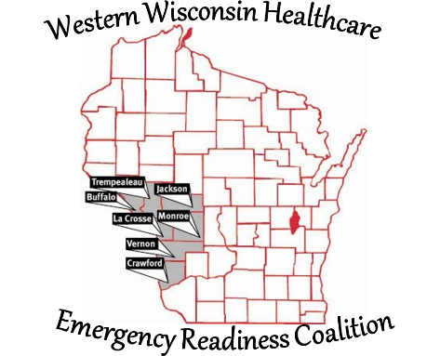
Western Wisconsin Healthcare Emergency Readiness Coalition
Buffalo Crawford Jackson La Crosse Monroe
Trempealeau Vernon Counties & Ho-Chunk Nation

Date of Implementation: June 29, 2026
WWHERC Indirect Funds, Policy #8

Budgeting indirect costs is allowable and optional for HERC regions. In addition to the federal indirect cost information provided in the ASPR HPP 2024-2028 Cooperative Agreement Funding Policies and Limitations section above, subrecipient grantee HERCs are expected to follow the Wisconsin DHS Allowable Cost Policy Manual. Subrecipient grantee agencies budgeting for indirect costs and claiming indirect costs in invoices submitted to Wisconsin DHS are expected to have a documented indirect cost policy. Documentation of this policy must be made available to OPEHC upon request.

- The Western Wisconsin Healthcare Emergency Readiness Coalition (WWHERC) will collect indirect costs whenever allowable.
- The Wisconsin Department of Health Services (WI DHS) has approved the WWHERC indirect cost rate of 10%. Designated public grant indirect funds can be used towards indirect expenses by the HERC that are allowable under the requirements of the Hospital Preparedness Program (HPP) grant.
- When received Indirect Costs will become part of the WWHERC’s Cash Balance.
- The Cash Balance will utilize indirect funds for standard business operations.
- The WWHERC executive board will determine how the WWHERC’s cash balance will be utilized and spent.
- The WWHERC will maintain accounting records of all funds and expenditures.
- The cash balance may be used for standard business operations. Expenses paid out of this category include, but are not limited to, technology, software, office supplies, checks, insurance, PO Box, etc.
- The cash balance may be utilized to pay up front for items that are in an approved budget when waiting for reimbursement is not practical.
- The cash balance may be utilized to allow the WWHERC to continue coalition business between budget periods including, but are not limited to, funding contracts and other board approved monthly and annual expenses.
- Refer to 45 CFR 75.414, Indirect Costs, and to the DHS Allowable Costs Policy Manual, for more information.

