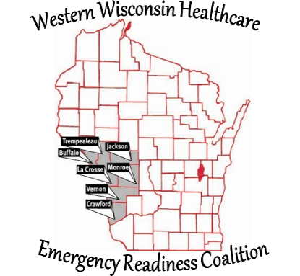
Western Wisconsin Healthcare Emergency
Readiness Coalition
Buffalo Crawford Jackson La Crosse Monroe
Trempealeau Vernon Counties & Ho-Chunk Nation

Implementation Date: August 5, 2021

Whistle Blower, Policy #4

The Western Wisconsin Healthcare Emergency Readiness Coalition – Region 4 Inc. (HERC) will not retaliate against a whistleblower. This includes, but is not limited to, protection from retaliation in the form of an adverse employment action such as termination, compensation decreases, poor work assignments, and threats of physical harm. Any whistleblower who believes he/she is being retaliated against must contact any member of the Executive Board of Directors immediately. The right of a whistleblower for protection against retaliation does not include immunity for any personal wrongdoing that is alleged and investigated.

Whistleblower protections are provided in two important areas: confidentiality and retaliation. Insofar as possible, the confidentiality of the whistleblower will be maintained. However, identity may have to be disclosed to conduct a thorough investigation, to comply with the law, and to provide accused individuals their legal rights of defense.

Individuals protected include:
a. the employee, representative, member, contractor, or any person acting on behalf of the person, who reports to a public body or is about to report to a public body a matter of public concern; or
b. the employee, representative, member, contractor, or anyone who participates in a court action, an investigation, a hearing, or an inquiry held by a public body on a matter of public concern.

The organization may not discharge, threaten, or otherwise discriminate against a person regarding compensation, terms, conditions, location, or privileges of employment or affiliation. The organization may not disqualify an employee or other person who brings a matter of public concern or participates in a proceeding connected with a matter of public concern, before a public body or court, because of the report or participation, from eligibility to bid on contracts with the organization; receive land under a district ordinance; or receive another right, privilege, or benefit.

The provisions of this policy do not
a. requires the organization to compensate anyone for participation in a court action or in an investigation, hearing, or inquiry by a public body;
b. prohibits the organization from compensating anyone for participation in a court action or in an investigation, hearing, or inquiry by a public body;
c. authorizes the disclosure of information that is legally required to be kept confidential; or
d. diminishes or impair the rights of anyone under a collective bargaining agreement.

Limitation to protections
a. A person is not entitled to the protections under this policy unless he or she reasonably that the information reported is, or is about to become, a matter of public concern; and reports the information in good faith.
b. A person is entitled to the protections under this policy only if the matter of public concern is not the result of conduct by the individual seeking protection, unless it is the result of conduct by the person that was required by his or her employer.
c. Before anyone initiates a report to a public body on a matter of public concern under this policy, the person shall submit a written report concerning the matter to the organization’s Executive Board of Directors. However, the person is not required to submit a written report if he or she believes with reasonable certainty that the activity, policy, or practice is already known to the Board; or that an emergency is involved.

Relief and penalties
a. A person who alleges a violation of this policy may bring a civil action and the court may grant appropriate relief.
b. A person who violates or attempts to violate this policy may also be liable for a civil fine of not more than ten thousand dollars ($10,000.00).

Procedures
I. If anyone has knowledge of or a concern of illegal or dishonest/fraudulent activity, the person is to contact any member of the Board of Directors. All reports or concerns of illegal and dishonest activities will be promptly submitted to any Officer of the Board or to the President of the Board, who is responsible for investigating and coordinating any necessary corrective action. Any concerns involving a Board Member should be reported to the President of the Board.
II. The whistleblower is not responsible for investigating the alleged illegal or dishonest activity, or for determining fault or corrective measures; appropriate management officials are charged with these responsibilities.
III. Examples of illegal or dishonest activities include violations of federal, state, or local laws; billing for services not performed or for goods not delivered; and other fraudulent financial reporting. The reporting person must exercise sound judgment to avoid baseless allegations. Anyone who intentionally files a false report of wrongdoing will be subject to disciplinary action.

Definitions
1. “Whistleblower” is defined by this policy as a person who reports, to one or more of the parties specified in this policy, an activity that he/she considers to be illegal, dishonest, unethical, or otherwise improper.

2. “Employee,” or “public employee,” means a person who performs a service for wages or other remuneration under a contract of hire, written or oral, express or implied, for the NEW HERC.

3. “Matter of public concern” means
a. a violation of a state, federal, or municipal law, regulation, or ordinance;
b. a danger to public health or safety; and/or c. gross mismanagement, substantial waste of funds, or a clear abuse of authority.

4. “Public body” includes an officer or agency of
a. the federal government;
b. the state;
c. a political subdivision of the state including a municipality or a school district; and
d. a public university in the state.

