Responding to a GENERAL ANNOUNCEMENT in EMResource (WI Trac)
Login: https://emresource.juvare.com/login
Click on announcement banner at the top of the home page. Note that general announcements are a purple banner.
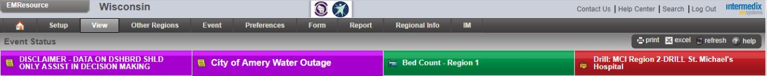
Clicking on announcement banner displays response screen. Click on dash under “Acknowledge” column and check “Yes” to acknowledge announcement. Enter any requested responses in comments free text field if applicable (eg responding to resource request or listing alternative phone number, etc.). Click “Save”.
