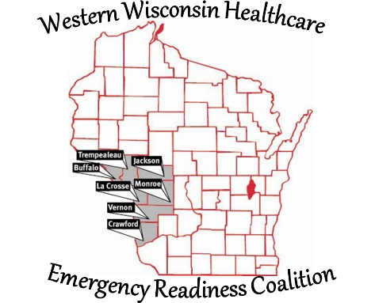
Western Wisconsin Healthcare Emergency Readiness Coalition
Buffalo Crawford Jackson La Crosse Monroe
Trempealeau Vernon Counties & Ho-Chunk Nation

Dan Henderson – Chairperson
Western Wisconsin Healthcare Emergency Readiness Coalition
C/O Black River Health
711 West Adams Street
Black River Falls, WI 54615
715-284-3469
Email: hendersond@blackriverhealth.com

WWHERC Purchasing Process
- A Funding Request Form must be completed by any member requesting WWHERC grant funding.
- All completed Funding Request Forms must be submitted to the WWHERC Coordinator.
- The WWHERC Coordinator will review each request to ensure all required information has been completed.
- The WWHERC Coordinator will forward each request to the WWHERC Grant Administrator (grant signer).
- The WWHERC Grant Administrator will determine if the funding request aligns with grant parameters.
- If the request aligns with grant parameters, the Grant Administrator will notify the WWHERC Coordinator.
- The WWHERC Coordinator will present requests that align with grant parameters to the Executive Board.
- The Executive Board will decide whether the request will be:
  - Denied,
  - Tabled pending additional information,
  - Approved utilizing indirect funds,
  - Approved utilizing indirect funds with intent to modify the budget and seek DHS approval at a later date, or
  - Approved pending DHS approval and budget modification.
- If approved, the WWHERC Coordinator will notify the requester.
- The requester will purchase the service or items.
- When services are complete or items are received, the requester will submit an invoice to the WWHERC Coordinator.
- The WWHERC Coordinator will verify the invoice amount, receipt of items and completion of services.
- The WWHERC Coordinator will submit the invoice to the Fiscal Agent.
- The Fiscal Agent will process the invoice based on the Board’s approval determination.
  - The WWHERC Chairperson, Vice Chairperson or Treasurer will approve the expense as required.

If any step in the process is not approved, the WWHERC Coordinator will notify the requester. The requester may be provided with a reason for the denial and, if applicable, may submit a new request following this process.

Daniel K. Henderson - Chairperson
Western Wisconsin Healthcare Emergency Readiness Coalition, Inc. (WWHERC)

